Bug_id_01
Bug Description:
Full Name field accepts unlimited Alphabets with no validation. Very long names can break UI layout, affect database storage, or cause display issues.
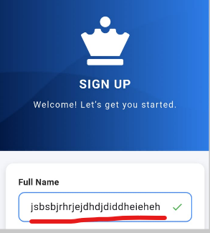
Bug_id_02
Bug Description:
Full Name field accepts unlimited spaces between words, allowing names like "hhh hhhh hhhhh hhhh". No validation for extra/repeated spaces.
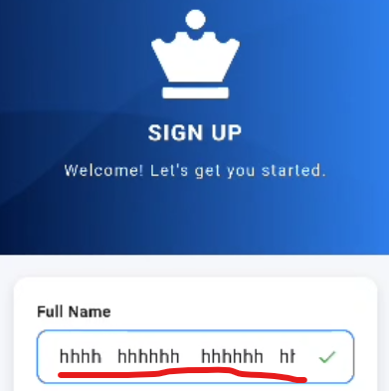
Bug_id_03
Bug Description:
Full Name field shows a truncated error message:
"Name should contain only alphabets and ..."
The trailing "..." makes the message incomplete and unclear to the user.
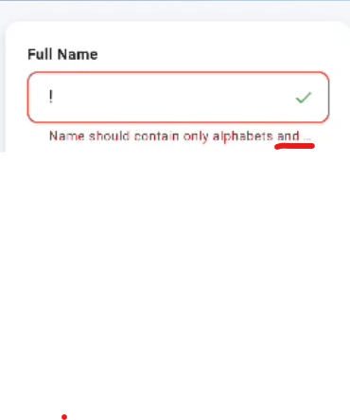
Bug_id_04
Bug Description:
Email field accepts unlimited characters with no length validation, which can cause UI overflow, backend issues, or invalid email format acceptance.
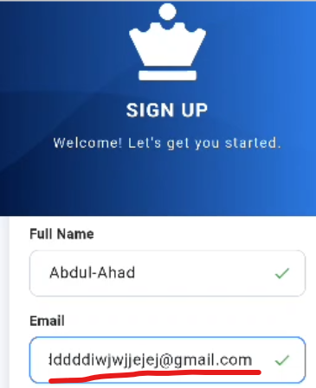

Bug_id_05
Bug Description:
Email field shows both "Invalid email" error and a validation tick (success icon) at the same time when entering invalid data which is contradictory.
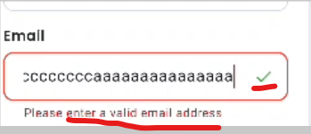

Bug_id_06
Bug Description:
Password field does not show any hint or validation message (e.g., "Use at least 6 characters, 1 uppercase, 1 number, 1 special character") when the user focuses on it. This can lead to weak passwords or user confusion.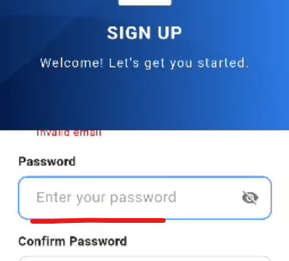

Bug_id_07
Bug Description:
Password error message shows incomplete text ending with "..." (e.g., "Password must contain at least one uppe..."). This makes the validation unclear and confusing to the user.
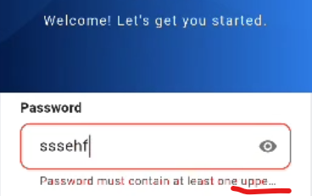

Bug_id_08
Bug Description:
Password validation shows errors one by one (first capital letter, then symbol, then number) instead of displaying all requirements at once, making the process confusing and repetitive for the user.
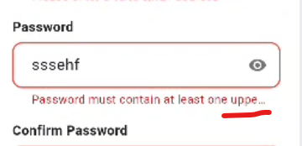
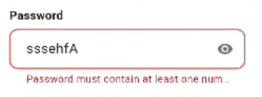
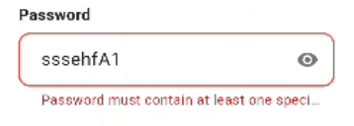

Bug_id_09
Bug Description:
Password and Confirm Password fields accept unlimited characters with no maximum length validation, which may lead to UI issues, backend errors, or security concerns.
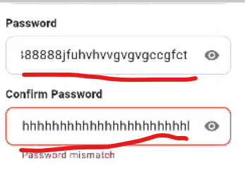

Bug_id_10
Bug Description:
"Already have an account? Login" link is positioned too far to the right side, causing poor alignment and inconsistent UI layout on the Sign Up screen.
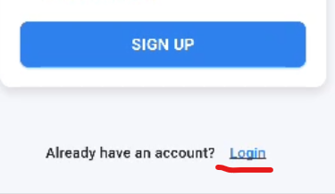
Bug_id_11
Bug Description:
Email field accepts incomplete and wrong domain format (e.g., "ahad@h.ii") and wrongly shows a validation tick, misleading the user.
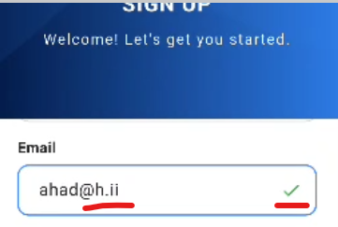

Bug_id_12
Bug Description:
Email field accepts invalid local-part (e.g., "+@gmail.com") and wrongly shows a validation tick, even though email format is incorrect.
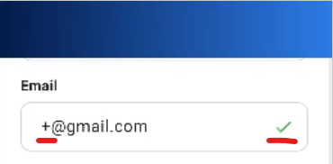

Bug_id_13
Bug Description:
When rotating the phone to horizontal (landscape) mode on the Sign Up screen, the UI does not adjust properly — only the logo and heading are visible, while the input fields are squeezed into a small space at the bottom, requiring excessive scrolling and making the form difficult to view or use.

